Grade 7 Accelerated · Unit 3 · Lesson 4  Negative Exponent Law  Independent Set 3.04 | Name______________________  Date______________________  Period____________________

Six questions, on your own, in silence. Show the step that does the work.
1. Rewrite with a positive exponent. Do not evaluate. 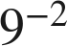

2. Find the value. 

3. Find the value. 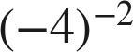

4. Find the value. 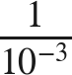

5. Find the value. 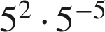

6. Find the value of . 